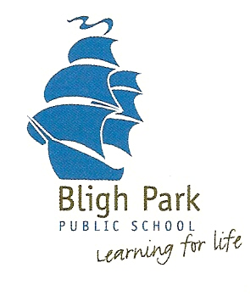24 July 2018

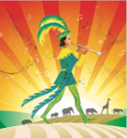

**Opera Australia comes to Bligh Park Public School**

**‘The Magic Flute’**

**Monday 30July, 2018**

Dear Parent/Caregiver,

Each year Opera Australia presents a national tour of a fully-staged opera, specially designed to tour metropolitan, regional and remote communities across Australia, giving people young and old their first experience of opera. Opera combines drama, music, design and movement in a way which heightens the expression of emotions and feelings. Once again the students of Bligh Park Public School are fortunate enough to have the opportunity to experience a live operatic performance by Opera Australia.

*‘The Magic Flute’* is one of Mozart’s most popular operas and had its world premiere in Vienna in 1791. Opera Australia has adapted ‘*The Magic Flute’* for school performances, allowing students to enjoy this mysterious and wonderful tale that follows four young peoples’ journeys as they discover their own strengths and weaknesses and pass the tests of true love. Its story of truth and light, friendship and forgiveness, told with enchanting music, has delighted school students across NSW and Victoria and will no doubt be enjoyed by the students at Bligh Park Public School.

The 60-minute performance will be held in the school hall and includes a question and answer session for the students at the conclusion of the performance. Performances will be divided into a K-Year 2 session and Years 3-6 session.

There is **no cost** **to students** for the performance as the school has been able to cover the cost of the performance through equity funding. All students are expected to attend this wonderful performance.

**When:** Monday 30July 2018

**Where:** Bligh Park Public School hall

**Cost**: Nil (school funded - low socio economic funding will cover the cost of $8.00 ex gst

per student for this performance)

If you have any questions please feel free to enquire through the school office.

Kind regards,

Mrs Belinda Gatt

Organising Teacher